Juan Pablo de Legarreta
IT 215 – Scripting
Lab 1
1. Tell me about yourself including your profession background and what you hope to get out of this course.
Hello! My name is Juan Pablo de Legarreta. I currently work at St. Xavier High School as part of their DEI team and have been working in non-profits for about a decade now, mostly working with youth in education and in youth ministry. I have been interested in computers and IT as long as I can remember, taking programming classes in high school and always acting like a de facto IT person in all of my places of employment. I graduated summa cum laude from Seton Hall University with a BA in Modern Languages (Russian and Arabic), where I also majored in Philosophy and Catholic Studies. I am very good at communicating with people, public speaking, training and curriculum development, taking complex concepts and turning them into ELI5 or tl;dr, and helping others. Inspired by watching some friends make the shift to IT, I am looking to shift careers into tech, eventually to Cybersecurity. I even volunteer with a non-profit called Raices Cyber, whose goal is to get more people into the industry, as their Sr. Director of Education. I oversee the development of their adult and youth courses. I am super excited to keep helping others in a new industry!
2. Have you programmed before? If so, what languages and how long?
I took C++, HTML, and Java in high school and then took up Python in my spare time after college. I have not really seriously coded outside of that, but I am quite familiar with syntax, concepts, and basic coding logic and norms.
3. Provide a screenshot that shows what version of python you have installed.
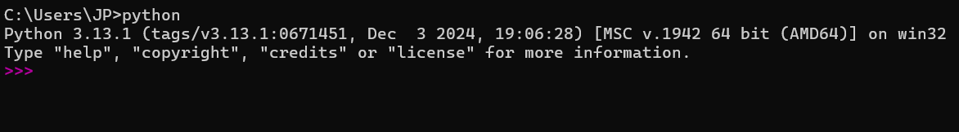
4. Do you have any questions about python, automation, or programming?
Truthfully, I don't yet know what I don't know - I am excited to learn about the extent that automation can be a part of my work and future career. I am most excited at the moment about learning automation and implementing it in my daily life!
5. What extension do python files leverage?
.py
6. What do you plan on writing your python code in (e.g. VS Code, VIM, Atom, Notepad++, etc)?
I will be using VS Code moving forward, though I have used PyCharm in the past.
7. What does IDE stand for and why would someone use one?
An IDE is an Integrated Development Environment. IDEs are applications that incorporate many features that help programmers to develop code more efficiently. These features include code editing, testing, and packaging. These features make the coding process run more easily and efficiently.
8. What is the built in IDE that comes with python?
IDLE
9. What were the 2 words I had python print to the screen as a part of week 1's lecture (this should be the first two words I had python print once we validated python was installed and the version)?
You had it print "hello wolrd", which I have also misspelled quite a few times!
10. Assuming I included python in my PATH when installing, how would I run a python file named “hello_world”.
python ./hello_world.py

